**Kitchen Story**

Screenshots:

1. Home page

1. Admin Login

1. Successful Admin Login

1. Failed Admin login – validation of login credentials

1. Change password

1. Successfully changed the password

1. Skip the change password window

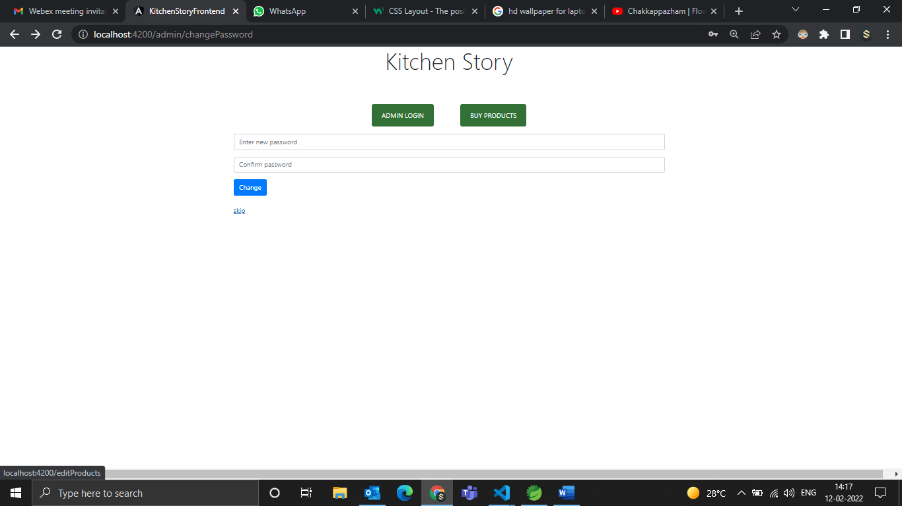

1. Master list of all products in the database

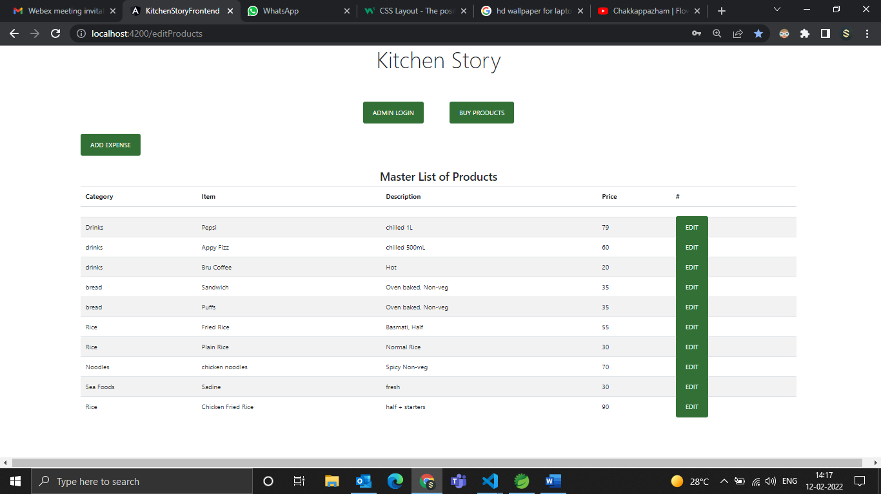

1. Edit the product in database

1. Updating data

1. Updated data

1. Delete a product

1. Product deleted

1. Db after deleting the product

1. Adding a product

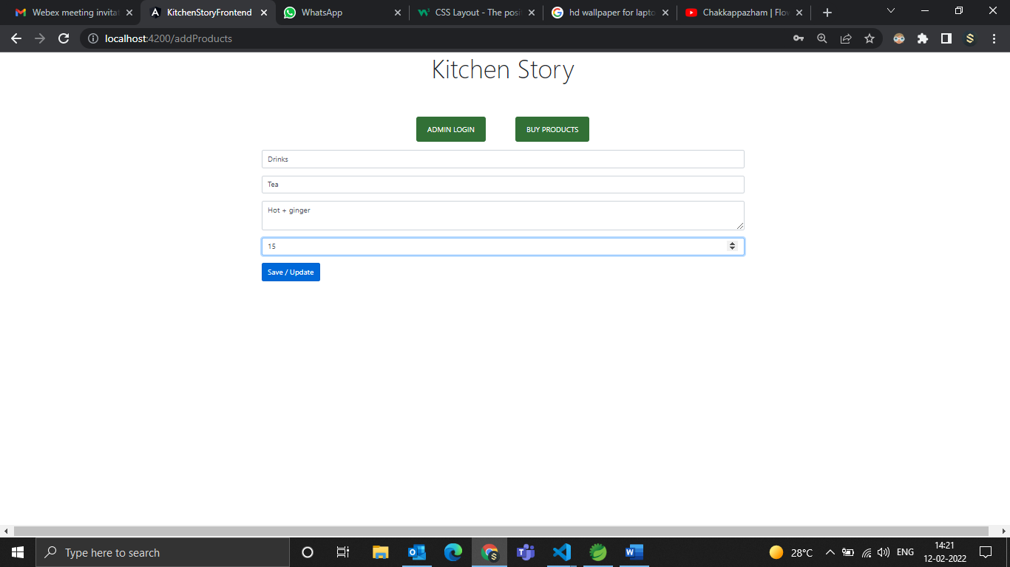

1. Product added to DB

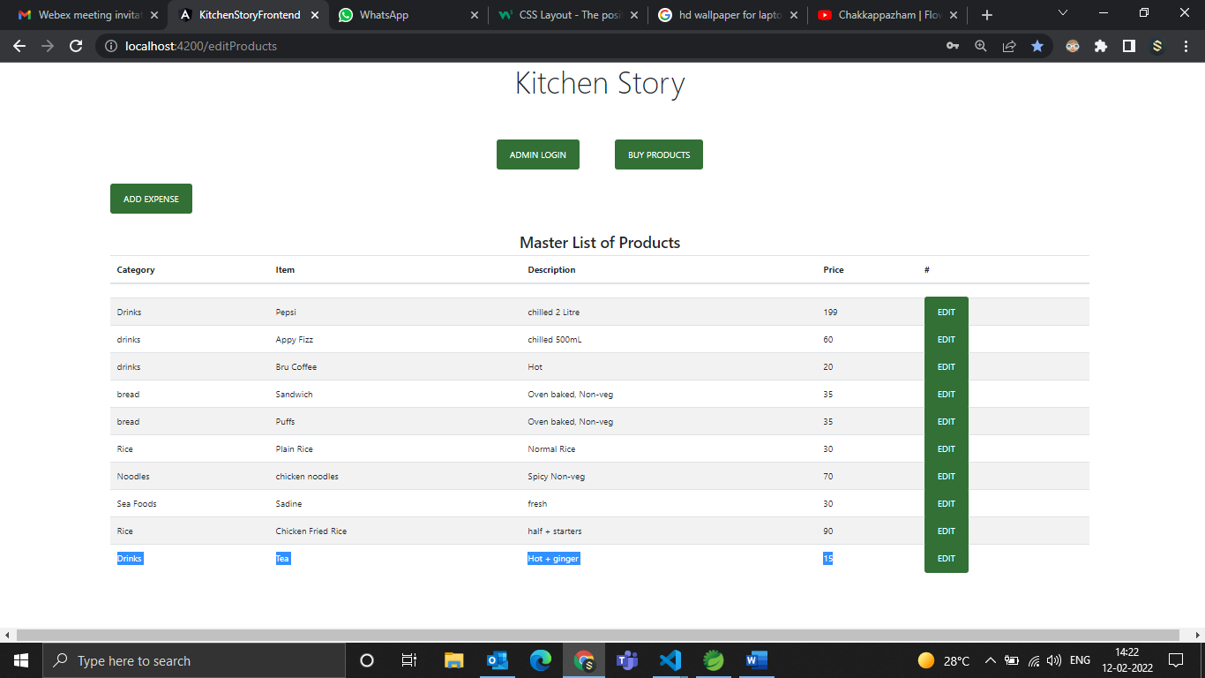

1. UI for buying the products

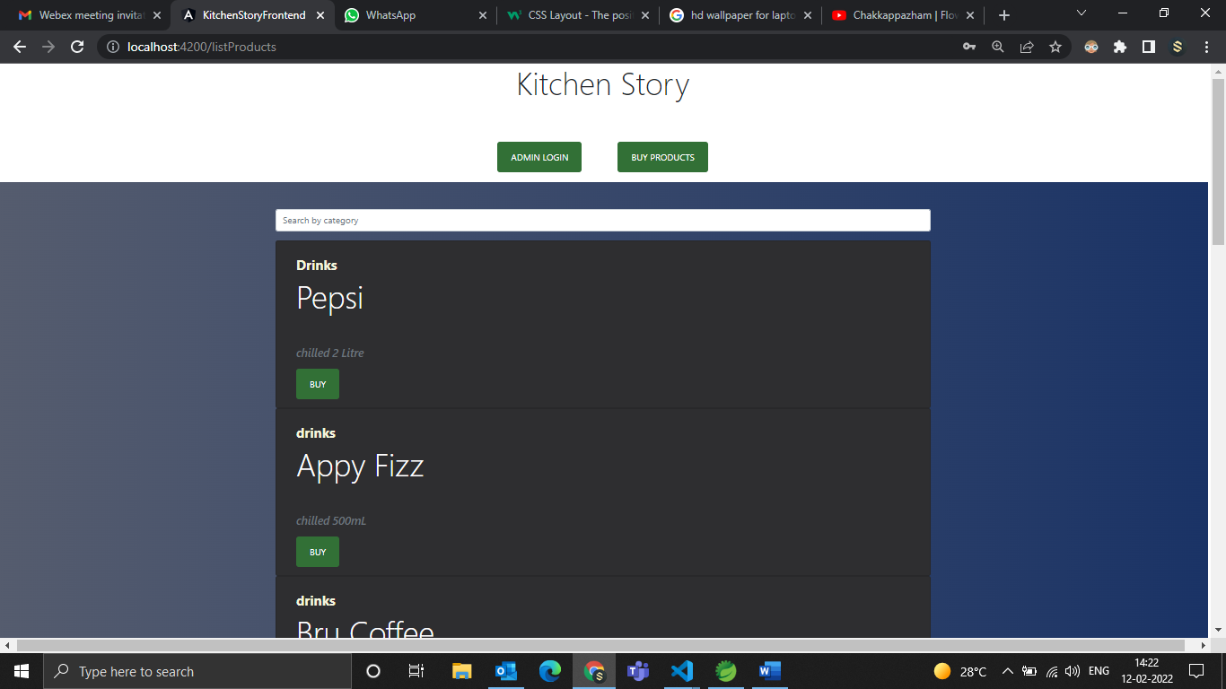

1. Search filter

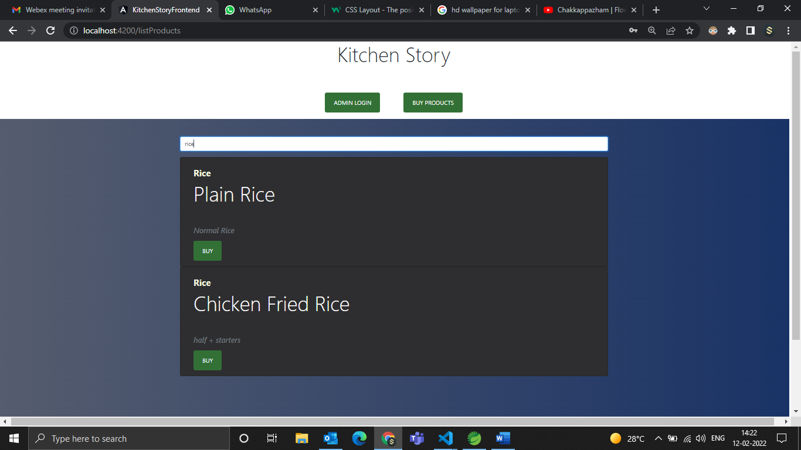

1. Selecting the product to buy

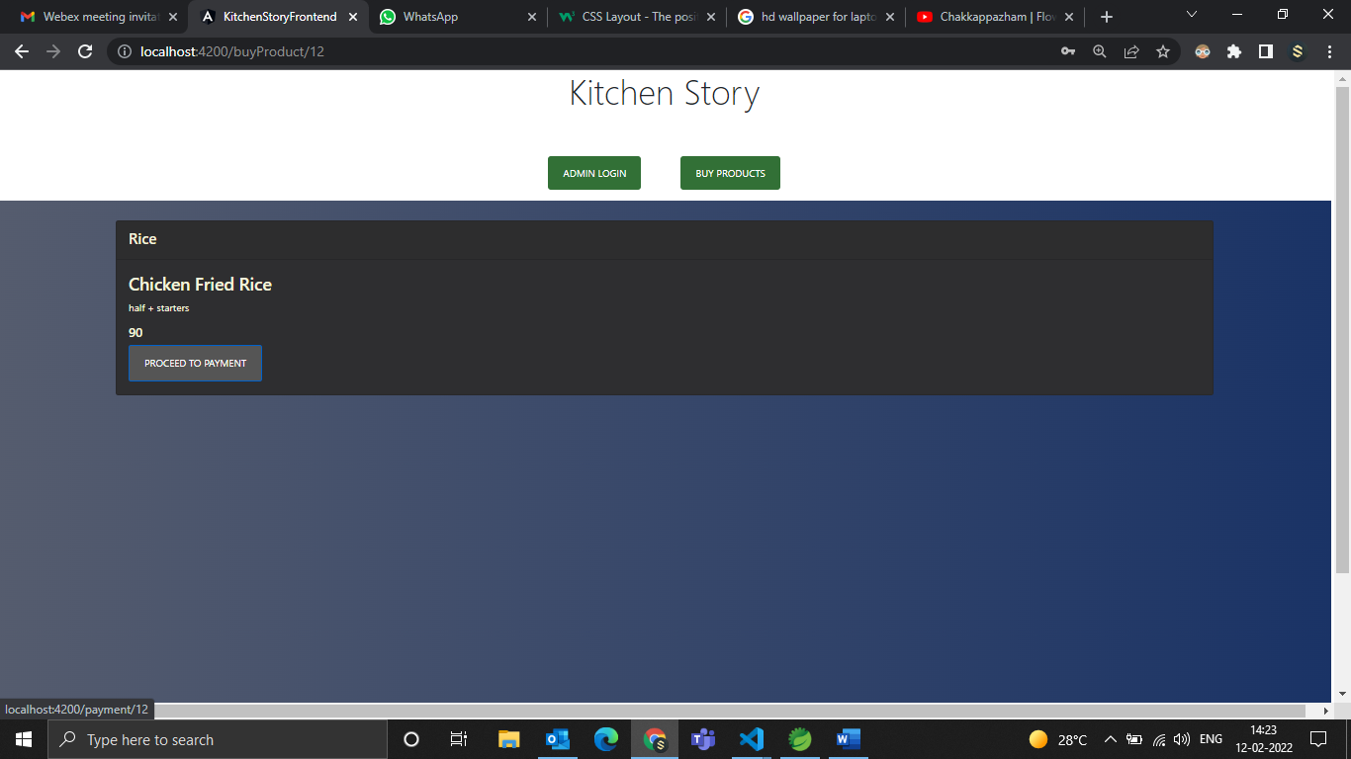

1. Payment portal

1. Product ordered successful – confirmation

